# Aws vpc Task -1

1. Create VPC with 2 private and 2 public subnets.

* First created a vpc using Ip no 172.168.0.0/24 and named it Vpc task1

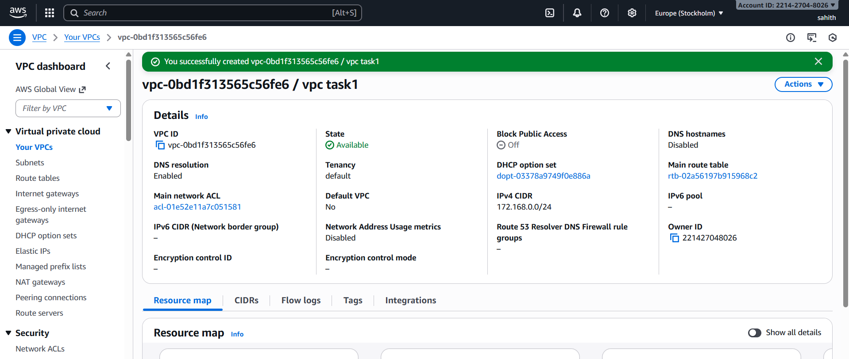

* Created subnet: private 1 with ipv4 CIDR 172.168.0.0/28

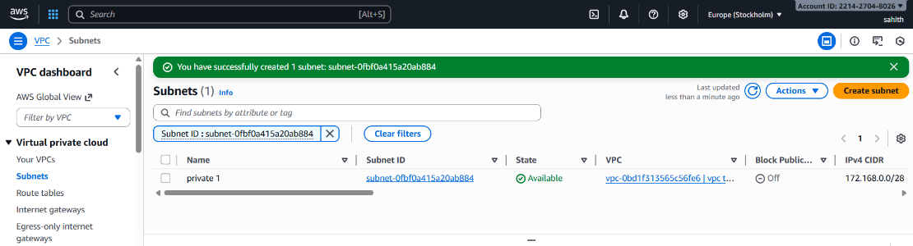

* Created subnet: private 2 with ipv4 CIDR 172.168.0.16/28

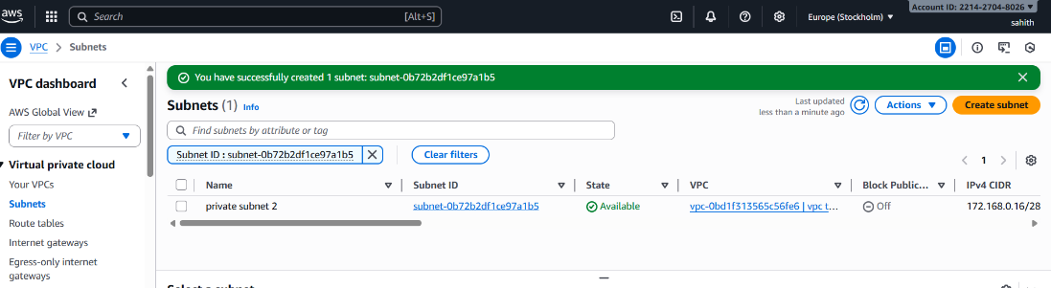

* Created subnet: public1 with ipv4 CIDR 172.168.0.32/28 and public 2 with ipv4 CIDR 172.168.0.48/28

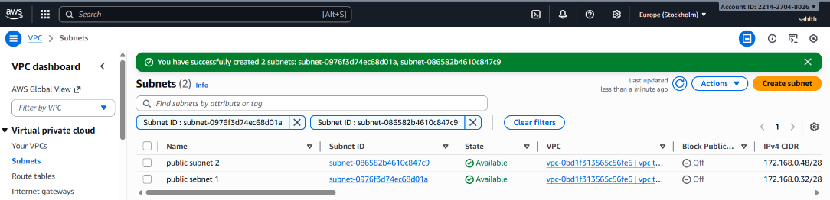

1. Enable DNS Hostname in VPC.

* Select on your vpcs > select on vpc > actions > Edit vpc settings > enable DNS Hostname > save

1. Enable Auto Assign Public IP in 2 public subnets.

* First select subnets > select on public subnet 1 > Actions > edit subnets settings > select on enable auto-assign public IPV4 address > save.

* First select subnets > select on public subnet 2 > Actions > edit subnets settings > select on enable auto-assign public IPV4 address > save.

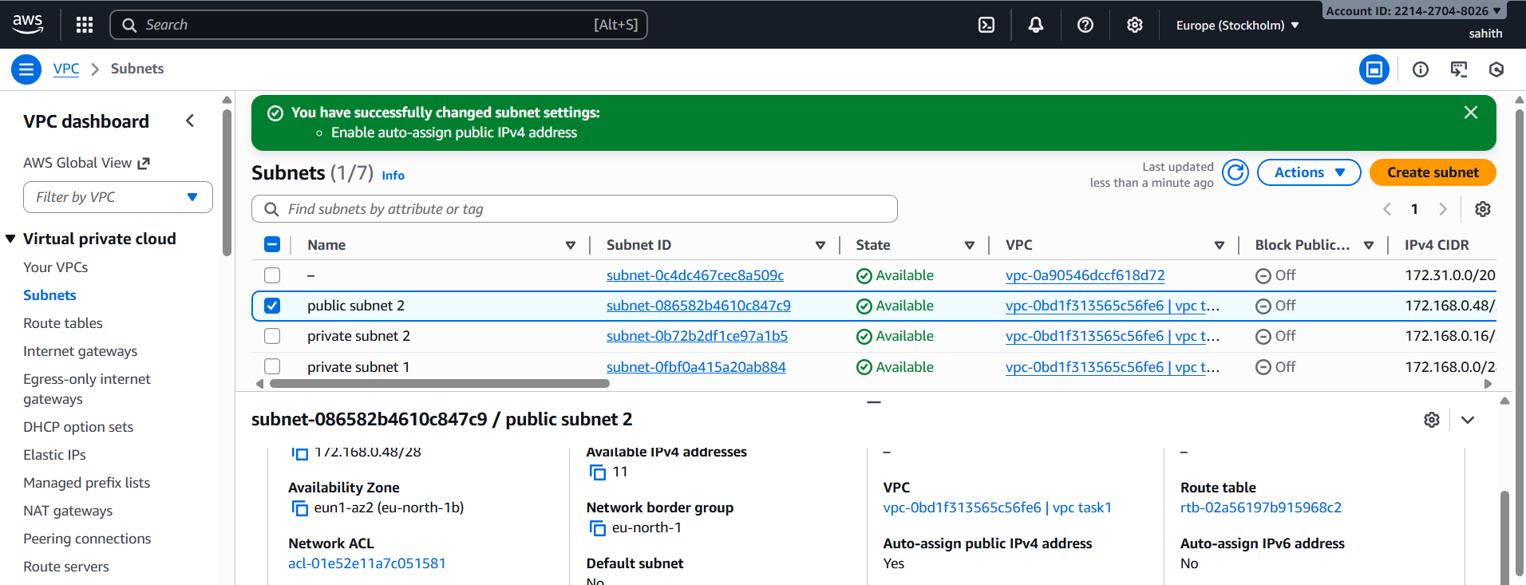

1. Add 2 private subnets in private route table.

* First select an option route tables from dashboard and create route table.
* Now select private route table > actions > edit subnet associations

* Now, select 2 private subnets > click on save associations.
* Now, we can see below that subnets are added to route table.

1. Add 2 public subnets in public route table.

* First select an option route table from dashboard and created public route table.
* Now select public route table > actions > edit subnet associations

* Now, select 2 public subnets > click on save associations.

* Now, we can see below that subnets are added to route table.

1. Public route table will have the routes to internet and local.

* Select internet gateways from dashboard > create internet gateway, gave an name to it as public route table internet and save
* Select public route table > actions > attach vpcs > save

* Now, come back to route tables select public route table > actions > edit routes.

* Select add route and in select internet gateway in drag options and select ip and save.

* Here we can see it is added and active.

1. Create EC2 in public subnet with t2.micro and install PHP.

* Created an ec2 instances and named it php server. in network settings added vpc id and select public subnet 2, select default security group.

* Using ssh link connected to git bash, switched to root user use commands
* sudo yum update -y
* yum install php

* yum install httpd php -y
* systemctl start httpd
* systemctl enable httpd
* systemctl status httpd
* echo "<?php phpinfo(); ?>" > /var/www/html/index.php
* sudo echo "<?php phpinfo(); ?>" | sudo tee /var/www/html/phpinfo.php

* http://<Public-IP>/index.php and using our ip address we can check the status in browser.

1. Configure NAT gateway in public subnet and connect to private instance.

* Created an vpc and named it Task q8

* Created 2 subnets 1 is public “ public subnet q8 1” and other is private “ private subnet q8-1”

* Created 2 route tables subnets 1 is public “ public q8 1” and other is private “ private q8 1”

* Created internet gateways named it task q8 and attach it into vpc.

* Attach subnet of public q8 into public RT in subnet association section

* Created NAT GATEWAY and select public connectivity and attach public subnet into it.
* Generate elastic ip while authorizing nategateway.

* Changes routes in route tables , apply igw for public route and subnet
* Apply nat gateway for private route.

* Launched 2 instances one for private and other for public

* Cat private key and copy it, copy ssh link from public instances and paste it in git bash, check it using ping google.com

* Vi test.pem and paste copyed private key, chmod 600 test.pem
* Now using ssh -I test.pem ec2-user@ “enter private ip address here”
* Change the internet using ping google.com

1. Install Apache Tomcat in private EC2 and deploy a sample app.

* Sudo yum update-y > sudo yum install java > wget https://dlcdn.apache.org/tomcat/tomcat-9/v9.0.112/bin/apache-tomcat-9.0.112.tar.gz

* Now, unzipped the file renamed it into tomcat > cd tomcat > cd bin. Using command ./startup.sh and output shows that tomcat started.

* Cd to webapps/ and get sample.war url from browser wget <https://tomcat.apache.org/tomcat-7.0-doc/appdev/sample/sample.war>
* Cd sample/ > vi index.html if want make somes and save. Cd > curl http//:172.168.0.22:8080

1. Configure VPC flow logs and store the logs in S3 and CloudWatch.

* Open vpc > create flow logs > filter(All) > Max (1min) > destination (send to cloud watch logs) > log record format( Aws default format) > Create flow log

* Search cloudwatch > select logs > log groups > here we can see all logs below.

* We can see all the logs here in below

* Created an s3 bucket and named it q10-buck
* Copied ARN id from s3 bucket and created new fowlog in subnets > public subnet and configured and pasted arn link and created.

* Now, we can see the logs below.

